Jason Sim

Lab 3

Part 2 of Lab 3

Created text file Lab3.data.txt.

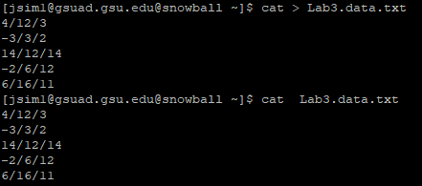

First awk file to convert strings to knuts: Question1.StringToKnuts.sh

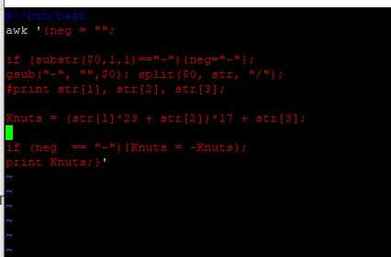

I created OutputKnuts.txt to show the result of the awk file above:

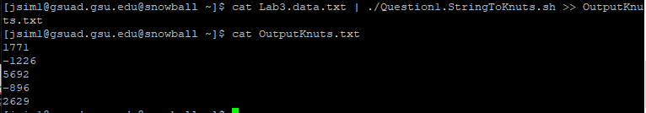

Second awk file converting knuts to strings: Question2.KnutsToString.sh

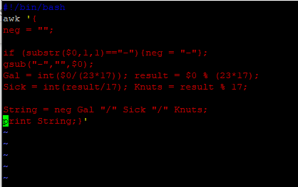

Creating OutputStrings.txt from the awk file above:

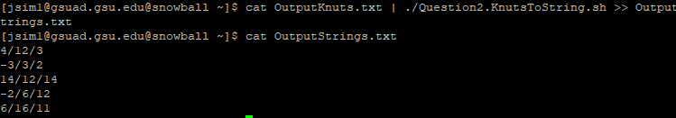

Command line to sum the Knut values from OutputKnuts.txt file. :



Assigning the above command line to Question3.SumKnuts file:



From file Question3.SumKnuts, I created Question3.SumStrings to show sum of strings:

